**Exercise 4-1 Format the Town Hall home page**

In this exercise, you' ll format the home page that you built in exercise 3-1 by

using the skills that you've learned in this chapter. When you're through, the

page should look like this.

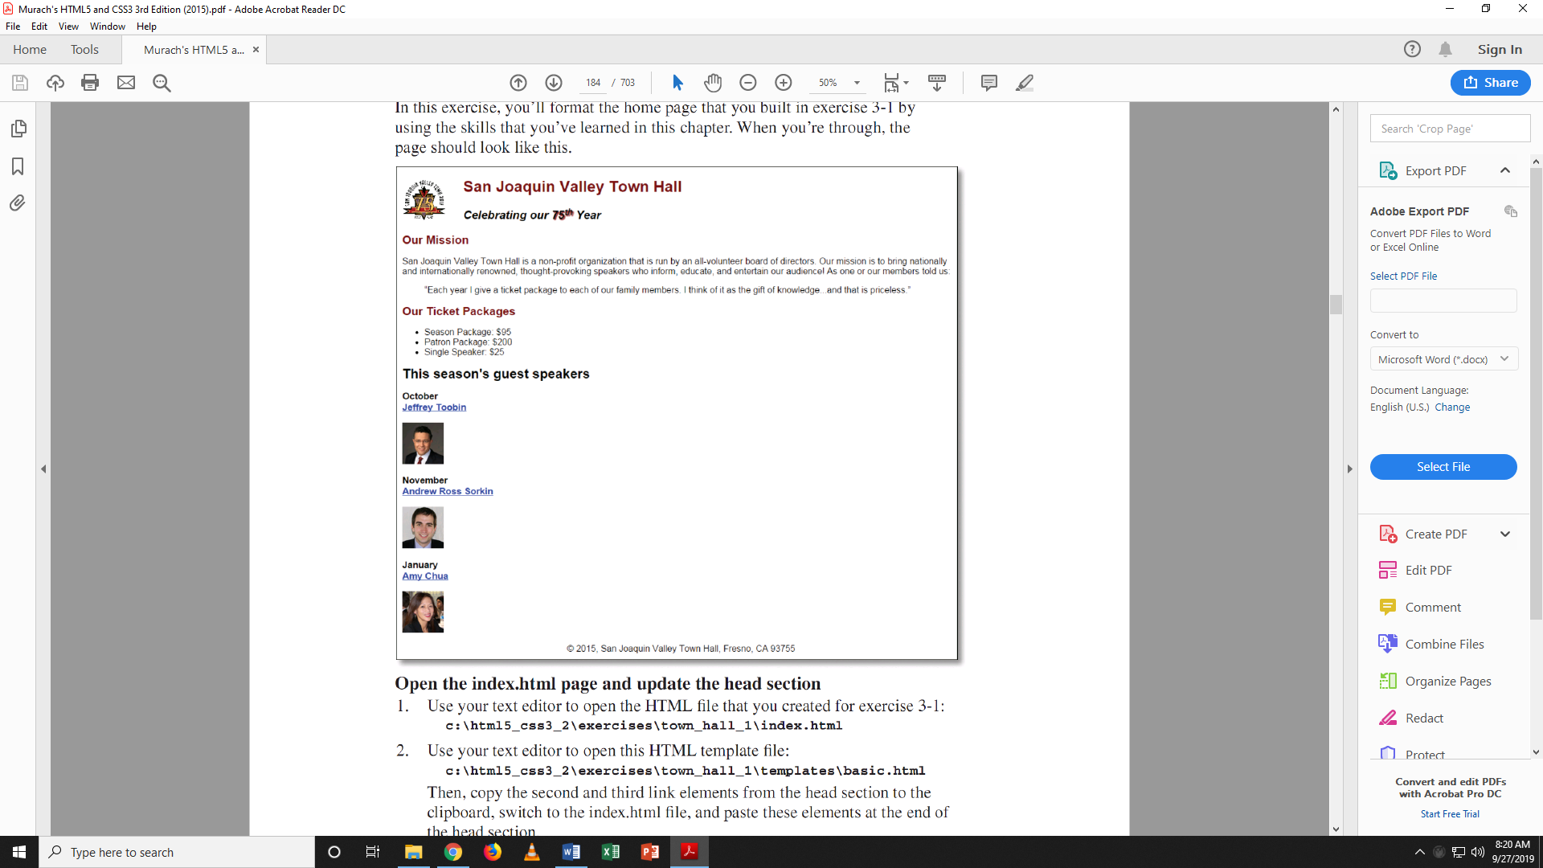

**Open the index.html page and update the head section**

1. Use your text editor to open the HTML file that you created for exercise 3-1:

index.html

2. Use your text editor to open this HTML template file:

basic.html Then, copy the link elements from the head, switch to the index.html fi le, and paste these  
  
 elements at the end of the head section.

3. Note that the first link element you just copied into the head is for the

normalize.css style sheet. Next, complete the href attribute in the second link element so it refers to the   
  
main.css file in the styles subfolder. Then, close the template.

**Open the main.css file and format the header**

4. Use your text editor to open this CSS file:

main.css

Note that this file contains some of the CSS code that you'll need, including

the rule set that specifies the font family and font size for the body, the rule set

that floats the image in the header, and the rule set that clears the floating in

the main element.

5. Add two rule sets for the header to the style sheet. The first one should be

for the h2 element, and it should set the font size to 170%, set the color to

#800000, and indent the heading 30 pixels. The second one should be for the

h3 element, and it should set the font size to 130%, set the font style to italic,

and indent the heading 30 pixels.

6. Test the HTML page in Chrome to make sure that the style sheets have been

linked properly, the image has been floated, and the headings have been

formatted correctly. If necessary, make corrections and test again.

Format the main element and the footerFrom now on, test each change right after you make it.

7. Add a rule set for the h 1 elements within the main element that sets the font

size to 150%.

8. Add a rule set for the h2 elements within the main element that sets the font

size to 130% and the color to #800000.

9. Add a rule set for the h3 elements within the main element that sets the font

size to 105%.

10. Add a rule set that italicizes any link that has the focus or has the mouse

hovering over it.

11. Add a rule set that centers the <p> tag in the footer.

**Exercise 4-2**

**Write a sentence with the information from the textbook and or PowerPoints, for each term below.**

DOCTYPE: declaration: Set of rules for previous versions of HTML. Good practice to have it around.

HTML: It is NOT a language. Yet, some people want to say it is. Rules to show content on web pages.

empty tag: An element without anything in it. Like <br>.

Boolean attribute: When you have it, it is true. Otherwise, it’s null!! Just joking it’s false then.

Comment out HTML: <!-- I like your class because it has a plan-->

comment out CSS: /* Seriously! It is good. Thank you*/

white space: to produce space like &nbsp and <br>

rule set: Whatever goes inside two brackets

declaration: <Declare the !DOCTYPE On top all the time>

HTML validation: To check if there’s any errors.

Favicon: The stuff on top of your tab on browser. PUT it in MAIN folder please.

Metadata: For Google only. Shown on search.

block element: Any element that does not need <br> to be separated.

ordered list: A list which is orders “ol”. Can start from any number though.

unordered list: It’s a chaotic list!!

external style sheet: Has a css file and should be imported in head.

embedded style sheet: inside the element or section.

hexadecimal (hex) value: FFFFFF is opposite of 000000

id: A name for an element.

Class: to access some elements

font family: Five generic font family